Shenzhen Tongdazhi Technology Co., Ltd
TDZ-S286
Tripod Turnsitle
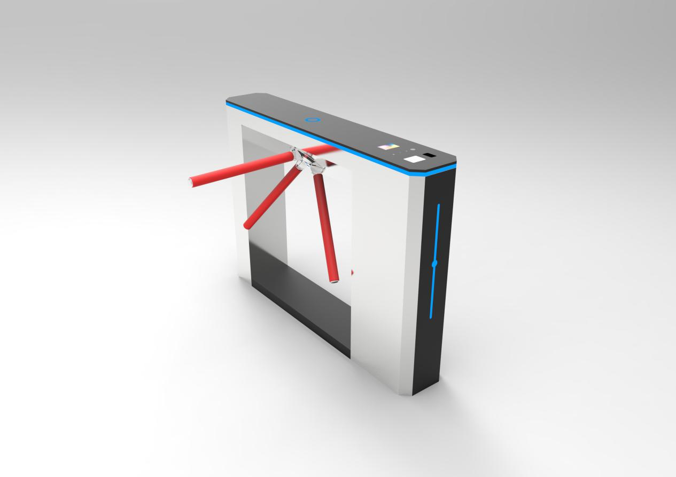
Feature
- Running stable without noise and mechanical impact
- Equipped with the dry contact signal input interface, compatible with all kinds of access controllers.
- After swiping card in normal condition, if within the permitting time passages do not pass, the system will
cancel the users’ pass right and arm close automatically
- Arm automatically open when the power off to make sure safety In case of emergency
- Optional for external counter to record the people numbers for each lane
- Single way or Bi-directional adjustable based on the requirement
- Equipped with LED directional indication / status lights
Occasion Application
Suitable for commercial buildings, subways, airports, customs, exhibition halls, government buildings, financial institutions, clubs and other high-end indoor applications.
Parameters
Structure parameters
Housing material | 304 grade stainless steel
Thickness | 1.5mm
Surface treatment | Brushed finish
Technical parameters
Size | 1400*240*1000mm
Lane width | 600mm
Passing speed | 35--50 people/min
Open/close speed | 0.2sec
Weight | 70KG
Turning angle | 120 degree
MCBF | 5.000.000 times
Application | Indoor or outdoor
Rotating directional | Single way or Bi-directional adjustable
Noise | <55db
Operating temperature | -25 to 70℃
Relative humidity | 5% to 95%
Package | Carton box inside. Wooden case outside
Electronic parameters
Power supply | 110-220V/AC, 50/60HZ
Rated power | 100W
Input signal | Dry contact
Driving motor | Solenoid
Method of position | Limiter

Basic Function
- The entry and exit directional can be set independently, free mode / forbidden model
- Direction indicator: The direction indicator is installed on the top of the housing cabinet to indicate the valid passing direction
- Compatibility: Equipped with dry contact signal input interface can make sure compatible with all kinds of access controllers
- Arm will drop down automatically when the power off. Which is meets the firefighting requirement
Customized Function
- Built-in or external counter
- External gate open button or remote controller
- 316 grade stainless steel. Thickness of the material
- Integrate with access control system and built-in reader appointed by customers.

